**PROJECT REPORT**

1. **INTRODUCTION:**
   1. **OVERVIEW:**

The Project, “Voyage Vista: Illuminating Insights from Uber Expenditionary Analysis” is about the customers experience while using this Uber Expenditionary in both beneficial and drawbacks.

* 1. **PURPOSE:**

The purpose of this project is to analyze the Uber Expenditionary is safe and comfortable or not. Uber calculate the customer into five catagories which are short trips, long trips, peak time, night time and normal time. So, this analysis helps the customers to use the uber in correct situation.

1. **PROBLEM DEFINITION & DESIGN THINKING:**
   1. **EMPATHY MAP:**

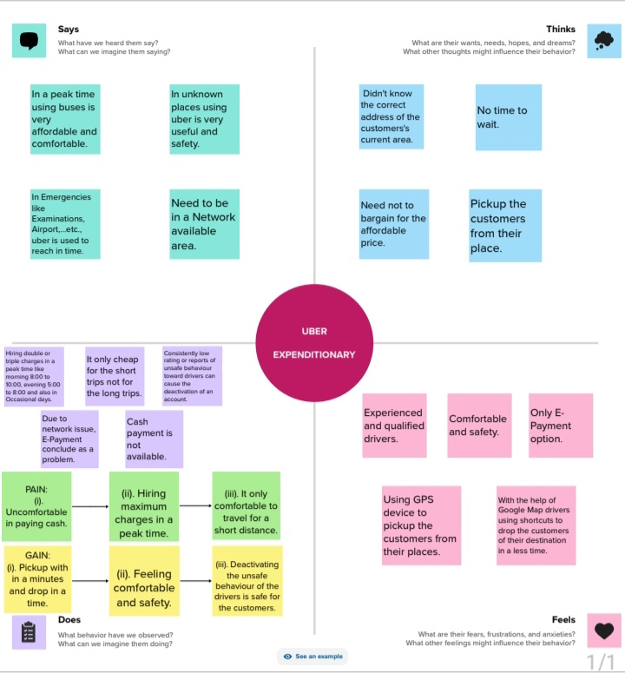

**2.2 IDEATION AND BRAINSTORMING MAP:**

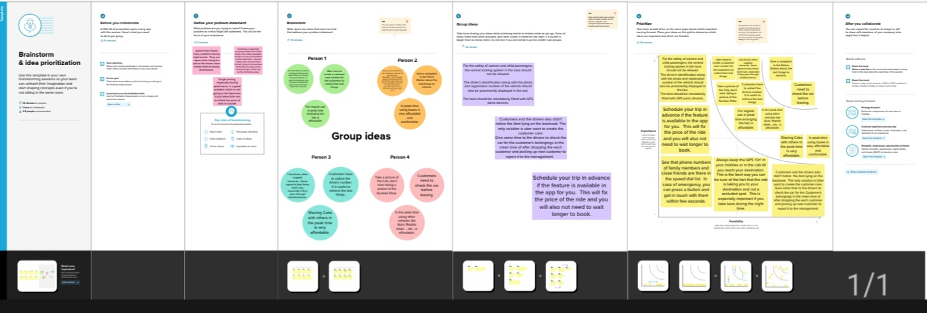

1. **RESULT:**

**Through the Visualizations, Dashboards and Stories, we conclude that the**

**Uber covered maximum miles at 2,851 for meetings.**

**Mostly Uber trips is used for Business**

**Maximum number of trips covered in the month of December by Uber.**

**In 2016, at the week 13 Uber reached maximum miles is 781.6.**

* 1. **DASHBOARDS:**

**DASHBOARD :1**

**In Dashboard 1, we categories the Quarter wise Uber Trips Analysis, Miles covered in category analysis, Month wise uber trips analysis and Week wise uber trips analysis.**

<https://public.tableau.com/views/UBEREXPENDITIONARYDASHBOARD1/Dashboard1?:language=en-GB&:display_count=n&:origin=viz_share_link>

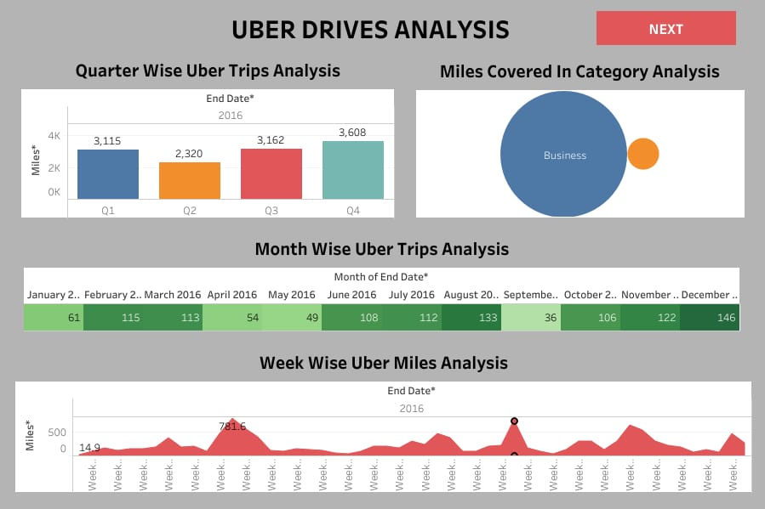

**DASHBOARD:2**

In Dashboard 2, we catagories the Miles covered category and purpose analysis, Quarter wise uber miles analysis, Hour wise Uber trips analysis and Month wise uber miles analysis.

<https://public.tableau.com/views/UBEREXPENDITIONARYDASHBOARD2/Dashboard2?:language=en-GB&:display_count=n&:origin=viz_share_link>

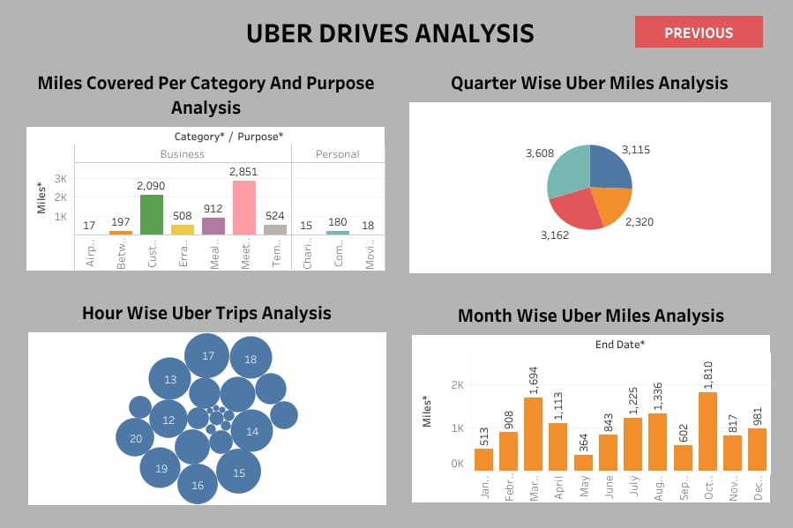

**3.2 STORIES:**

**STORY:1**

<https://public.tableau.com/views/UBEREXPENDITIONARYSTORY1/Story1?:language=en-GB&:display_count=n&:origin=viz_share_link>

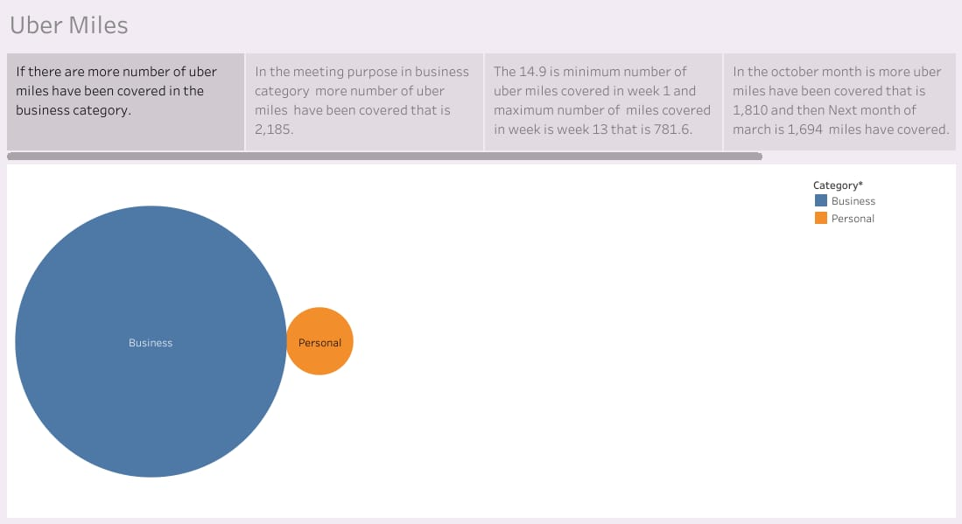

**STORY:2**

<https://public.tableau.com/views/UBEREXPENDITIONARYSTORY2/Story2?:language=en-GB&:display_count=n&:origin=viz_share_link>

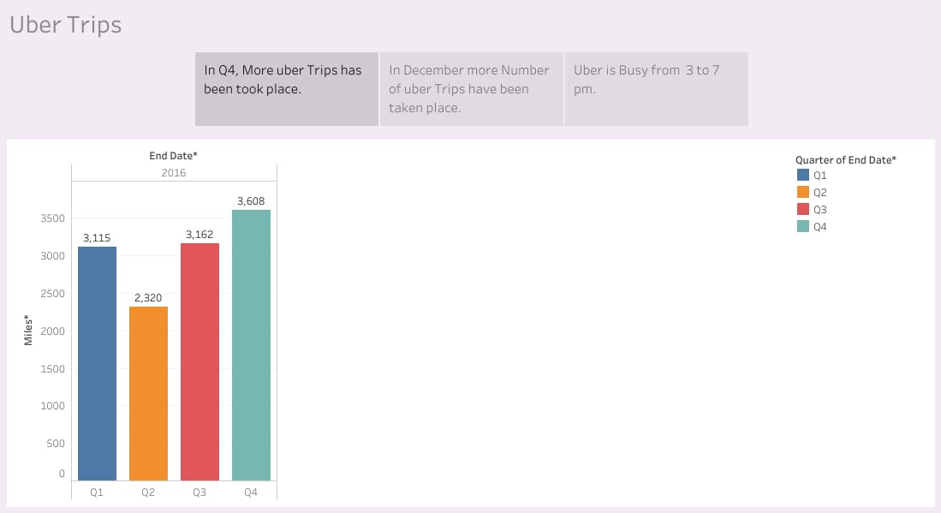

1. **ADVANTAGES & DISADVANTAGES:**

**ADVANTAGES:**

* Pickup with in a minutes and drop in a time.
* Feeling comfortable and safety.
* Deactivating the unsafe behaviour of the drivers is safe for the customers.
* With the help of Google Map drivers using shortcuts to drop the customers to their destination in a less time.
* Experienced and qualified drivers.
* Using GPS device to pickup the customers from their places.

**DISADVANTAGES:**

* Uncomfortable in paying cash.
* Hiring maximum charges in a peak time.
* It only comfortable to travel for a short distance.
* Due to network issue, E-Payment conclude as a problem.

**5. APPLICATION:**

The insights gathered from this project got a solution for the various problems experienced by the customers while using Uber Expenditionary.

* See that phone numbers of family members and close friends are there in the speed dial list. In case of emergency, you can press a button and get in touch with them within few seconds.
* Uber have to create a customer care number for the customers to collect their lost things. Otherwise, Customers have to collect the driver’s number. It is useful to retrieve the lost things.
* For regular use in peak time arranging the taxi is affordable. In peak time using buses is very affordable and comfortable. Sharing Cabs with other in the peak time is also very affordable. The another solution is in the peak time using other vehicles like Auto, Rapido bikes…etc., is affordable.

1. **CONCLUSION:**

In conclusion, this project gives the overview to the customer’s to how to use this Uber Expenditionary in all situations.

* In unknown places using uber is very useful and safety.
* In Emergencies like Examinations, Airport,….etc., uber is used to reach in time.
* In a peak time using other vehicles like auto, regular taxes, and buses is very affordable and comfortable.
* Using Uber with full security only always comfortable. Otherwise it will always miserable.

1. **FUTURE SCOPE:**

Future enhancements for this project could include:

* To develop Uber Expenditionary stop charging surge pricing in peak times.
* Create a customer care for the customers to retrieve their lost things.
* Design a new app to track the drivers while attending the customers for to analysis the drivers behaviour and their intension.